Part 1

Login in to service plus with the credential <http://tathyasathi.bangla.gov.in/configure/login.do>

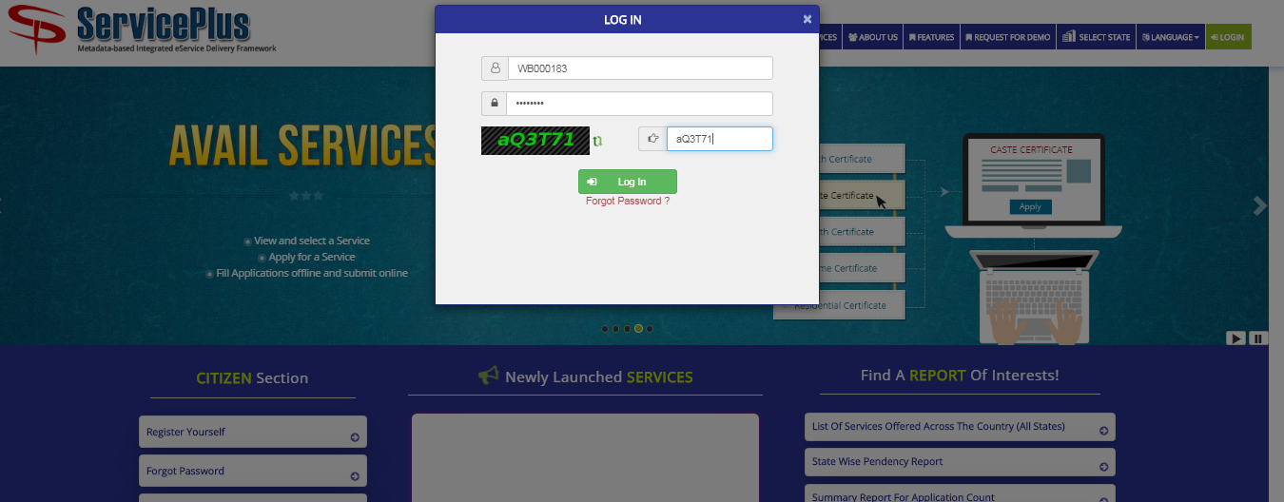

Fill the details .Activation link is received in the email so it should be correct and active. Be carefully in fill the information in this window. Full name should be like Gram Panchayat – BHAGIRATHPUR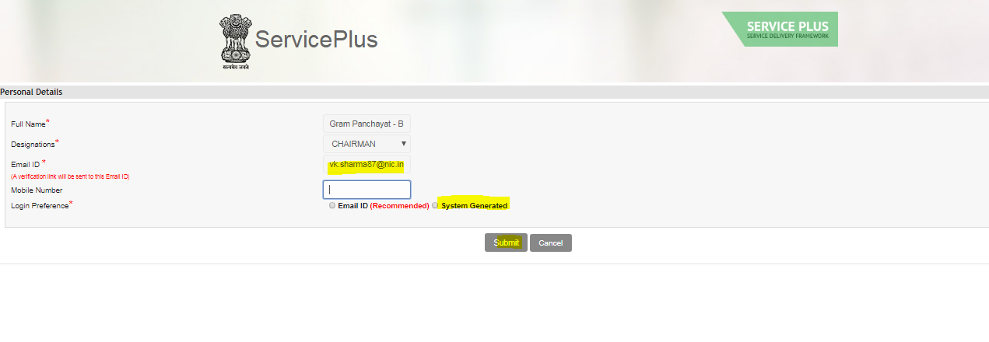

ServicePlus has sent a verification link on your Email ID vkxxxxx@nxxx.in. Please confirm your Email ID by clicking on the link and Reset Password.

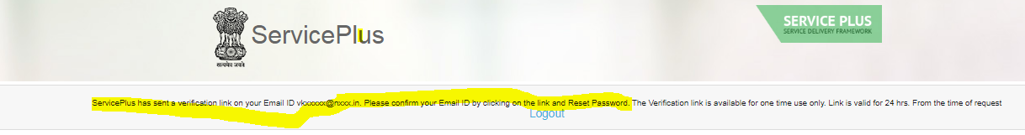

Open your email and click on the activation link and reset the password

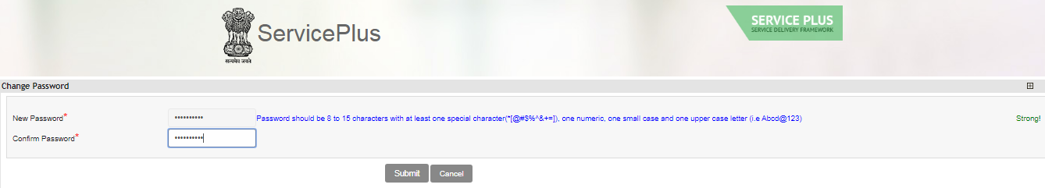

The request has been sent to your Admin for approval.

Part 2

Step to create computer operator user

Login as a panchayat department Admin in service plus. Create one user from user management option.

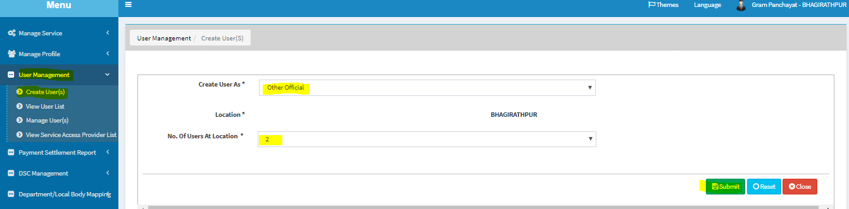

Users are created and details are sent to the registered email .

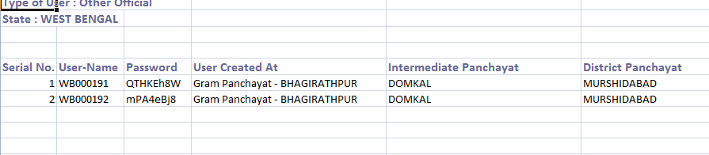

Login into service plus with the credential . Fill the details .Activation link is received in the email so it should be correct and active. Be carefully in fill the information in this window. Full name should be like Gram Panchayat – BHAGIRATHPUR-Computer Operator. Designation should be data entry operator

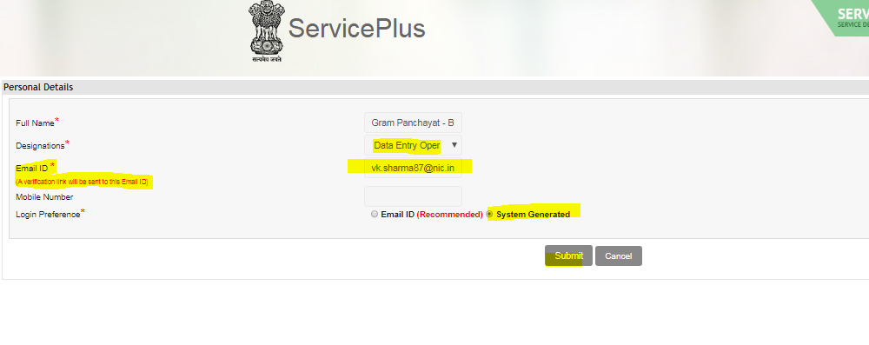

ServicePlus has sent a verification link on your Email ID vkxxxxx@nxxx.in. Please confirm your Email ID by clicking on the link and Reset Password

Open the mail and click on the link and reset the password

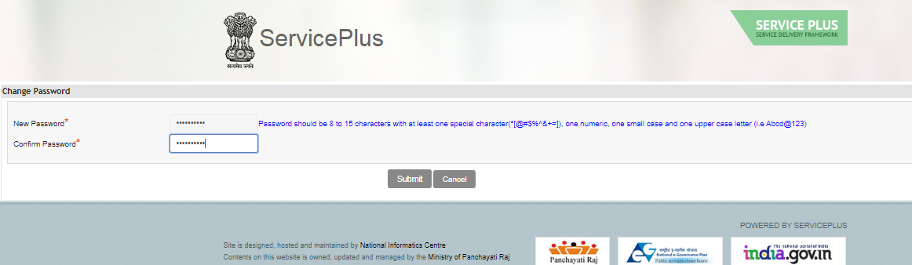

Login as a panchayat department Admin and approve the user

